DELHI TECHNOLOGICAL UNIVERSITY

# (FORMELY DELHI COLLEGE OF ENGINEERING)

# Shahbad Daulatpur,Bawana Road,Delhi-110042

# DEPARTMENT OF SOFTWARE ENGINEERING



**SE-203**

**DATA STRUCTURES**

**LAB FILE**

SUBMITTED TO: SUBMITTED BY:

Mr. Ankur Narwal Aradhay jain(23/SE/30)

Department Of Software Engineering

**INDEX**

|  |  |  |  |
| --- | --- | --- | --- |
| **S. No.** | **Objective** | **Date** | **Sign** |
| 1. | To reverse an array of characters | 21/08/24 |  |
| 2. | To perform various operations on array:   * Insert element * Delete element * Find largest element * Find smallest element | 04/09/24 |  |
| 3. | To perform string operations:   * Merge 2 strings * Reverse a string * Find and replace substring | 09/10/24 |  |
|  |  |  |  |
|  |  |  |  |
|  |  |  |  |
|  |  |  |  |
|  |  |  |  |

**EXPERIMENT-1**

**AIM:** To take input from user and reverse an array.

**CODE:**

#include<stdio.h>

#include<stdlib.h>

void reverse(int* arr,int n){

int i=0;

int j=n-1;

while(j>i){

int temp=arr[i];

arr[i]=arr[j];

arr[j]=temp;

i++;

j--;

}

}

int main(){

int n;

printf("input size:");

scanf("%d",&n);

int* arr=(int*)malloc(n*sizeof(int));

printf("enter data:");

for(int i=0;i<n;i++){

scanf("%c",&arr[i]);

}

reverse(arr,n);

for(int i=0;i<n;i++){

printf("%c",arr[i]);

}

}

**OUTPUT:**

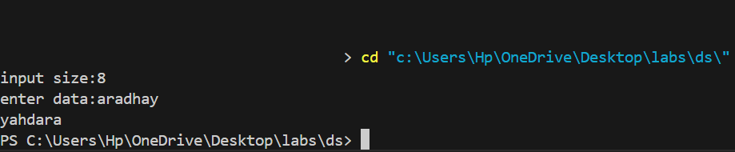

**EXPERIMENT-2**

**AIM:** To perform various operations on array:

* Insert element
* Delete element
* Find largest element
* Find smallest element

**CODE:**

#include<stdio.h>

#include<stdlib.h>

#include<conio.h>

void add(int *arr,int index,int value,int size){

if(size==0 && index==0){

arr[index]=value;

}

else{

for(int i=size-1;i>=index;i--){

arr[i+1]=arr[i];

}

arr[index]=value;

}

}

void deleteFromArray(int* arr,int index,int size){

if(size==0){

printf("no value to delete \n");

}

if(index==size-1){

arr[index]=-1;

}

for(int i=index;i<size;i++){

arr[i]=arr[i+1];

}

}

int findMax(int *arr,int size){

int maxi=-1e9;

for(int i=0;i<size;i++){

if(arr[i]>maxi){

maxi=arr[i];

}

}

return maxi;

}

int findMin(int *arr,int size){

int mini=1e9;

for(int i=0;i<size;i++){

if(arr[i]<mini){

mini=arr[i];

}

}

return mini;

}

void display(int*arr,int size){

for(int i=0;i<size;i++){

printf("%d ",arr[i]);

}

printf("size is:%d",size);

}

int main(){

char ch;

int arr[100];

int size=0;

while(1){

int choice;

printf("enter your choice:");

scanf("%d",&choice);

if(choice==1){

printf("enter value to add:");

int value;

scanf("%d",&value);

printf("enter index:");

int index;

scanf("%d",&index);

add(arr,index,value,size);

size++;

}

else if(choice==2){

int index;

printf("enter index to delete:");

scanf("%d",&index);

deleteFromArray(arr,index,size);

size--;

}

else if(choice==3){

printf("maximum element is %d \n",findMax(arr,size));

}

else if(choice==4){

printf("mainimum element is %d \n",findMin(arr,size));

}

else{

display(arr,size);

}

printf("to continue press y:");

getchar();

scanf("%c",&ch);

if(ch!='y'){

break;

}

}

}

**OUTPUT:**

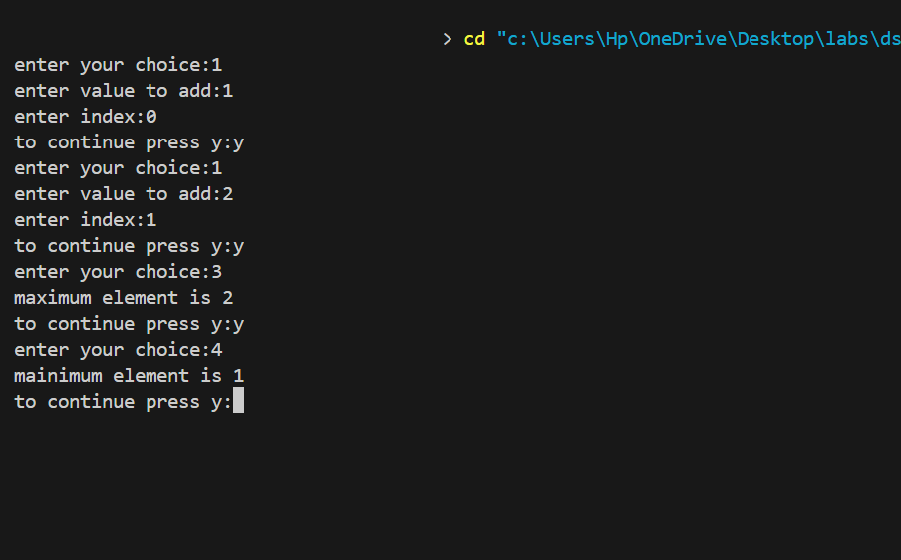

**EXPERIMENT-3**

**AIM:** To perform string operations:

* Merge 2 strings
* Reverse a string
* Find and replace substring

**CODE:**

#include <stdio.h>

#include <string.h>

#include <stdlib.h>

char* merge(char* str1, char* str2) {

int length = strlen(str1) + strlen(str2) + 1;

char* str3 = (char*)malloc(length * sizeof(char));

int k = 0;

for (int i = 0; i < strlen(str1); i++) {

str3[k++] = str1[i];

}

for (int i = 0; i < strlen(str2); i++) {

str3[k++] = str2[i];

}

str3[k] = '\0';

return str3;

}

void reverse(char* str1){

int i=0,j=strlen(str1)-1;

while(j>i){

char temp=str1[i];

str1[i]=str1[j];

str1[j]=temp;

i++;

j--;

}

}

char* substring(char* str,char* substr,char* replacestr){

int j=0,index,size=strlen(substr),flag1=0,flag2=0;

for(int i=0;str[i]!='\0';i++){

if(str[i]==substr[j]){

flag1=1;

int J=j;

int k=i;

while(size-1>0){

if(str[k]!=substr[J]){

flag2=1;

break;

}

J++;

size--;

k++;

}

index=i;

break;

}

}

if(flag1=1 && flag2==0){

int g=0;

while(substr[g]!='\0'){

str[index]=replacestr[g];

index++;

g++;

}

return str;

}

else{

return "No such substring";

}

}

int main() {

int choice;

char str1[50],str2[50],str3[50],str4[50],substr[30],newstr[30];

while(1){

printf("Enter your choice (1 to merge strings): ");

scanf("%d", &choice);

if (choice == 1) {

char str1[30], str2[10];

printf("Enter the first string: ");

getchar();

fgets(str1, sizeof(str1), stdin);

str1[strcspn(str1, "\n")] = '\0';

printf("Enter the second string: ");

fgets(str2, sizeof(str2), stdin);

str2[strcspn(str2, "\n")] = '\0';

char* str3 = merge(str1, str2);

printf("Merged string: ");

puts(str3);

free(str3);

}

else if(choice==2){

int n;

printf("enter length:");

scanf("%d",&n);

char* str1 = (char*)malloc(n * sizeof(char));

printf("enter word:");

getchar();

gets(str1);

reverse(str1);

puts(str1);

free(str1);

}

else if(choice==3){

printf("Enter main string : ");

getchar();

gets(str4);

printf("Enter substring : ");

gets(substr);

printf("Enter new substring : ");

gets(newstr);

puts(substring(str4,substr,newstr));

}

else{

printf("invalid choice");

}

printf("want to continue ?");

char c;

scanf("%c",&c);

if(c!='y'){

break;

}else{

continue;

}

}

return 0;

}

**OUTPUT:**

